**KATHMANDU UNIVERSITY**

**Proposal for**

RMS Merit Point

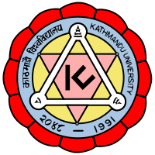

**Submitted to:**

Mr. Dhiraj Shrestha

(Project Coordinator)

Department of Computer Science and Engineering

School of Engineering, Kathmandu University

**Submitted by:**

Sujal Kokh Shrestha [016245-13]

Habibikram Thapa

Computer Science (Third year/Second semester)

Department of Computer Science and Engineering

School of Engineering, Kathmandu University

April 22th, 2016

For the partial fulfilment of semester project (COMP 313) as per the requirement.